Unit VIII: Emerging Trends in Software Engineering
CLOUD → AI → IoT/SUSTAINABILITY → SECURITY

1. Cloud-Native Development — 8 Marks
Covers:
- Cloud Native Development has largely impacted the development process. Discuss how?
- What are the advantages of cloud-native development?

Definition
Cloud-native development is an approach to building applications specifically for cloud environments using microservices, containers, APIs, automation, and scalable infrastructure.

Impact and Advantages — SCALE
- S – Scalability: Resources can increase or decrease according to workload.
- C – Continuous Deployment: CI/CD enables frequent and faster releases.
- A – Availability: Distributed services improve reliability and availability.
- L – Lightweight: Containers provide portable and consistent deployment.
- E – Efficiency: Cloud resources reduce infrastructure management and improve resource utilization.
Figure:microservices

2. Serverless Computing — 4 Marks

Definition
Serverless computing is a cloud model where developers run functions without managing the underlying servers; the cloud provider manages the infrastructure.

Features — SEA
- S – Stateless: Functions generally execute independently.
- E – Event-driven: Functions run in response to events.
- A – Auto-scaling: Resources automatically adjust to workload.

Figure

Examples
AWS Lambda, Azure Functions, Google Cloud Functions
Room Rent Example: A successful payment event can trigger a function to update booking status and send confirmation.

3. AI in Software Engineering — 8 Marks
Covers both:
- Role of AI in Software Engineering. How do AI-assisted coding and testing tools improve development?
- Short note: AI in Software Engineering.

Definition
AI in Software Engineering uses artificial intelligence to assist coding, testing, debugging, code review, documentation, and maintenance.

Major Applications — CODE
- C – Code Generation: Generates and completes code.
- O – Optimization: Suggests improvements to code.
- D – Debugging: Helps identify and fix errors.
- E – Evaluation: Assists testing and code review.

AI-Assisted Testing
AI can:
- Generate test cases.
- Identify potential defects.
- Analyze test results.
- Suggest regression tests.

Tools
Tool | Use
GitHub Copilot | Code generation/completion
DeepCode | Code analysis
ChatGPT | Coding, debugging and testing assistance

Benefits — PACE
- P – Increased productivity
- A – Improved code analysis
- C – Faster coding and testing
- E – Easier developer learning/onboarding

Limitations
- AI-generated code may contain errors.
- Security/privacy concerns may arise.
- Developers may become overly dependent on AI.
- AI may misunderstand project-specific requirements.
Room Rent Example: AI can generate unit tests for the Booking Service, but developers should review and validate the generated tests.

4. Sustainability in Software Engineering — 8 Marks

Definition
Sustainable Software Engineering develops and operates software while minimizing energy consumption, resource usage, waste, and environmental impact.

Why Sustainability Matters
- Software consumes computing and network resources.
- Data centers require electricity and cooling.
- Inefficient applications increase energy consumption.
- Hardware replacement contributes to e-waste.

Deployment Considerations — SMART
- S – Scale: Match resources with demand.
- M – Minimize: Reduce unnecessary computation and storage.
- A – Auto-scale: Automatically adjust resources.
- R – Release: Shut down unused resources.
- T – Technology: Use energy-efficient infrastructure.

Green Software Practices
- Optimize algorithms and database queries.
- Use caching to avoid repeated processing.
- Reduce unnecessary network communication.
- Use efficient cloud resources.
- Monitor CPU, memory, and energy usage.
- Prefer renewable-energy-based infrastructure where feasible.

Room Rent Example: Frequently searched room details can be cached to reduce repeated database processing.

5. Secure Software Development Practices — 4 Marks

Definition
Secure software development integrates security into all stages of the software development lifecycle.

Key Practices — LIE
- L – Least Privilege: Give users only necessary permissions.
- I – Input Validation: Validate and sanitize user input.
- E – Encryption: Protect sensitive data during storage and transmission.
- Security Testing: Identify vulnerabilities before deployment.
- Secure Authentication: Use strong authentication and authorization.

Room Rent Example: Only authorized owners can modify room listings, while payment information is encrypted.

Unit III — Requirements Engineering

3.1.1 Importance of Stakeholder Involvement
Introduction:
Stakeholder involvement means involving people affected by or interested in the system during requirements elicitation.

Importance — “OWN-RAC”
- O – Ownership & Satisfaction → Stakeholders feel ownership and satisfaction with the system.
- W – Wide Perspectives → Provides diverse perspectives and covers different use cases.
- N – Needs of Business → Ensures the system meets actual business needs.
- R – Risk Identification → Helps identify potential risks and problems early.
- A – Acceptance → Improves user acceptance of the final system.
- C – Communication & Collaboration → Improves communication and cooperation among stakeholders

Example — Rental System:
Owner, tenant and admin provide requirements for property management, rental approval and payment.
Conclusion:
Stakeholder involvement helps develop a correct, complete and acceptable system.

3.1.2 Challenges in Requirements Gathering
Introduction:
Requirements gathering may be difficult because stakeholders have different knowledge, goals and expectations.

Challenges — “C5”
- C – Communication Barriers → Stakeholders may lack technical knowledge, while developers may not understand domain-specific details.
- C – Changing Requirements → Requirements may change due to market, technology, or organizational changes.
- C – Conflicting Requirements → Stakeholders may have different priorities and opposing interests.
- C – Concealed (Unstated) Requirements → Stakeholders may assume some needs are obvious and fail to state them.
- C – Confusing (Ambiguous) Requirements → Vague or unclear requirements can cause different interpretations.
Importance:
Identifying these challenges prevents misinterpretation, scope creep and missing requirements.
Example — Rental System:
Owner wants detailed tenant information, while tenants require privacy, creating a requirement conflict.
Conclusion:
Clear communication, workshops and negotiation help obtain reliable requirements.

3.2.1 Completeness and Consistency
Introduction:
- Completeness: All necessary requirements are identified and included.
- Consistency: Requirements do not contradict each other and use uniform terminology.

Importance — “C²” 🧠
- C – Complete Requirements → Ensures no critical functionality is missing.
- C – Consistent Requirements → Ensures requirements do not contradict each other.
- R – Reliable SRS → Makes the SRS clear, reliable, and implementable.
- U – Uniform Terminology → Uses the same terms and concepts throughout the requirements.

Examples: Consistency and Completeness
- Consistency: In a room rental system, consistency ensures that the term “Tenant ID” is used uniformly instead of mixing terms like “Renter ID” or “Customer ID.”
- Completeness: Completeness ensures that all essential features, such as room search, booking, rent payment, tenant registration, and booking cancellation, are covered without gaps.
Conclusion:
Complete and consistent requirements reduce missing functionality and conflicts.

3.2.2 Clarity and Correctness

Clarity and Correctness
- Clarity: Requirements should be clear and unambiguous meaning.
Example: “Tenant can search rooms by price and location.”
- Correctness: Requirements should accurately meet stakeholder needs.
Example: “The system allows owners to list rooms and tenants to book available rooms.”
Importance:
Prevents misinterpretation and incorrect implementation.

3.2.3 Realism and Verifiability
Introduction:
- Realism: Requirement is feasible within available resources.
- Verifiability: Requirement can be objectively tested.
Importance:
Ensures requirements can be implemented and validated.

Realism and Verifiability
- Realism: The system should support 500 users with available resources.
- Verifiability: Booking confirmation within 5 seconds can be tested.
Conclusion:
A good requirement must be realistic and measurable/testable.

3.2.4 Traceability of Requirements
Introduction:
Traceability tracks a requirement throughout its lifecycle.
Figure:
Need → Requirement → Design → Code → Test
Importance:
- Tracks requirement changes.
- Supports impact analysis.
- Prevents missing requirements.
- Connects requirements with testing.
Example — Rental System:
R01: Online Rent Payment
↓
Payment Module → Payment API → TC01
Conclusion:
Traceability maintains requirement history and coverage.

Formal Technical Review (FTR) is a systematic team review of a software work product to find errors, verify requirements, and check standards before finalization.
C – Compliance with Standards
→ Ensures the software follows predefined standards.
E – Error Detection
→ Detects errors in function, logic, and implementation.
R – Requirement Verification
→ Verifies that software requirements are satisfied.
T – Training & Knowledge Sharing
→ Provides training and promotes knowledge sharing among engineers.
Q – Quality & Reliability
→ Improves software quality and reliability.
M – Manageable Projects
→ Makes software projects more manageable

Explanation of FTR Process According to the Figure

1. Planning
The team reviews the needs of the software work product and prepares a plan for conducting the Formal Technical Review.
Output: Plans

2. Preparation
The producer prepares and documents the review material. The instructor may provide guidance, and reviewers prepare an individual issues list before the meeting.
Output: Document and Individual Issues List

3. FTR Meeting
Reviewers discuss the prepared software document and consolidate the individual issues into a single issues list. The recorder records all issues raised during the meeting.
Output: Consolidated Issues List

4. Determine Corrections
The team examines the consolidated issues and determines the corrective actions required. The action items are sent back to the issues list for follow-up.
Output: Action Items

5. Revise
The team or producer revises the software document according to the assigned action items. The revised document is then sent for verification.
Output: Revised Document

6. Write Summary
The team prepares a review summary based on the identified issues. The summary records the review findings and conclusions.
Output: Review Summary

7. Verify
The reviewers verify that the corrective actions have been completed and the revised document satisfies the review requirements. The signed summary is used to produce the finished document.
Output: Signed Summary and Finished Document

Figure Flow
Team → Planning → Preparation
↑ ↓
└── Document Individual Issues
↓
FTR Meeting
↓
Consolidated Issues List
↓
Determine Corrections
↓
Revise
↓
Write Summary
↓
Verify
↓
Finished Document

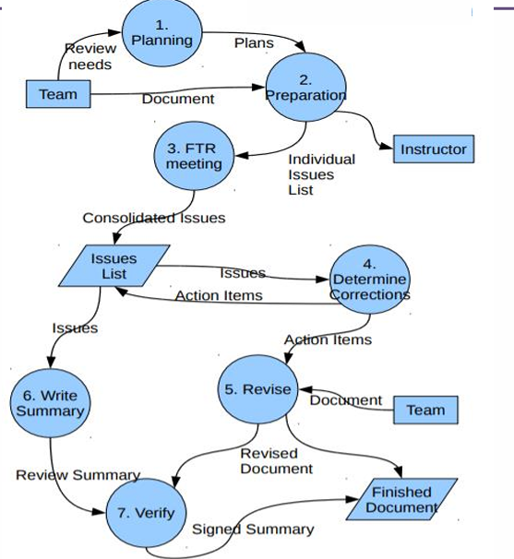

Chapter 1

Verification vs Validation
Verification | Validation
1. Are you building it right? | 1. Are you building the right thing?
2. Checks whether an artifact conforms to the previous artifact/specification. | 2. Checks the final product against the user requirements/specification.
3. Mainly done by developers/reviewers. | 3. Mainly done by testers/users.
4. Concerned with phase containment and correctness of intermediate artifacts. | 4. Concerned with whether the final product satisfies user needs.
5. Methods: Reviews, inspections, walkthroughs, unit testing, integration testing. | 5. Mainly involves system testing and acceptance testing.
6. Includes both static and dynamic activities. | 6. Mainly involves dynamic activities.

Simple Figure

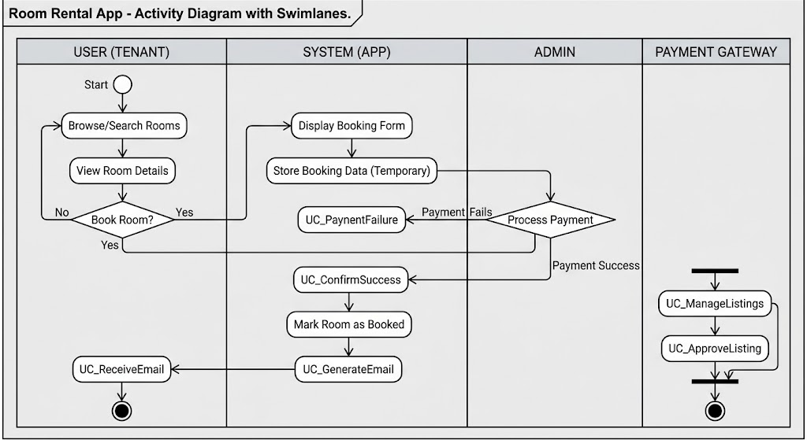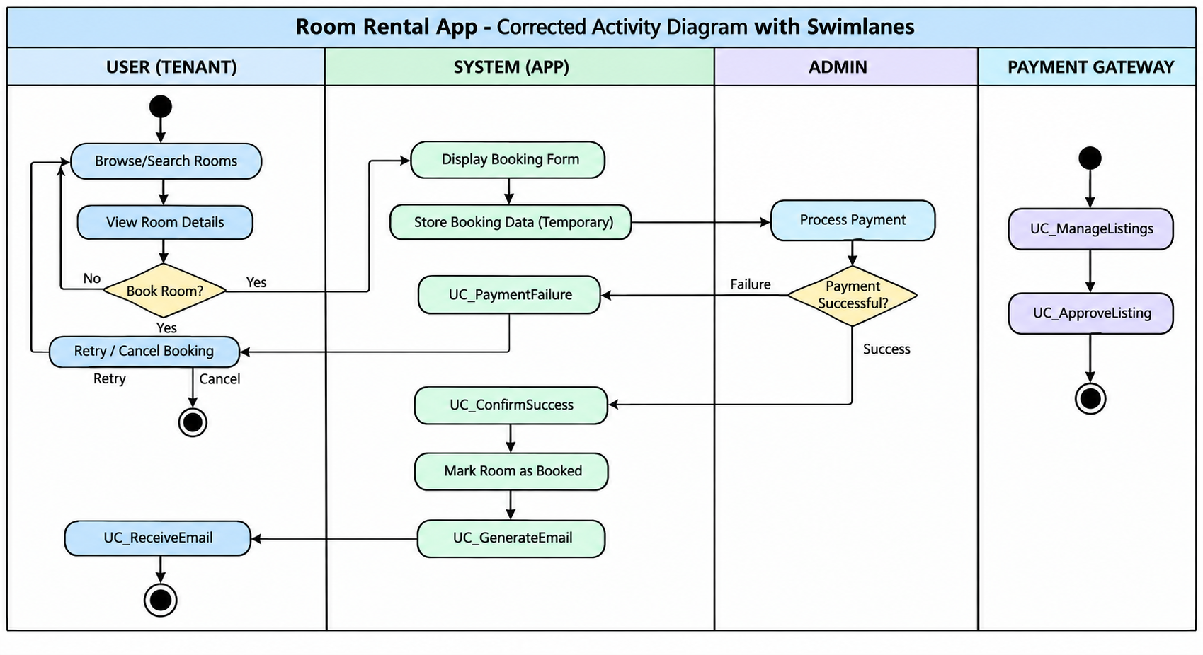Spiral Model — 4 Marks

Introduction
The Spiral Model, proposed by Barry Boehm, is a risk-driven evolutionary software process model. It combines iterative development and prototyping with systematic planning. The system is developed through repeated spiral loops, where each loop produces an improved version of the software.

Four Main Phases
- Determine Objectives, Alternatives & Constraints
Define objectives, requirements, alternatives, and constraints for the current iteration.
- Identify & Resolve Risks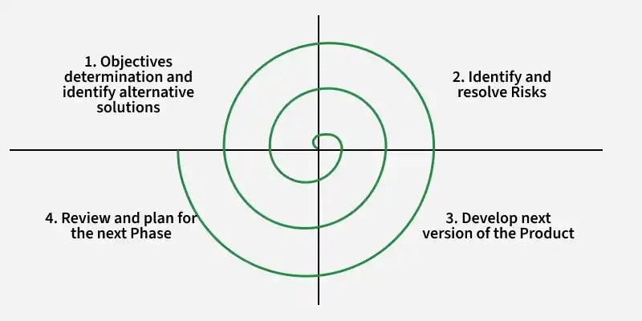
Analyze technical, security, cost, and requirement risks and resolve them using prototypes, testing, or analysis.
- Develop & Verify Next-Level Product
Design, code, integrate, and test the selected solution to produce the next version.
- Review & Plan Next Phase
Obtain stakeholder feedback, review progress, and plan objectives and activities for the next spiral loop.

Importance
- Risk reduction: Risks are identified and resolved early.
- Flexibility: Changing requirements can be incorporated in later loops.
- Early feedback: Prototypes and intermediate versions allow stakeholder evaluation.
- Suitable for complex systems: Useful when requirements, technology, or risks are uncertain.

Rental System Example
For an Online Rental System:
1. Objectives
→ Property registration, tenant search, booking
↓
2. Risk Analysis
→ Payment security, booking conflicts, data privacy
↓
3. Develop & Verify
→ Build and test property + booking module
↓
4. Review & Plan
→ Owner/Tenant feedback → Plan next version ↺
Example: In the first loop, the team develops property registration. After stakeholder feedback, the next loop adds tenant search and booking, followed by online payment and maintenance in later loops.

Conclusion
The Spiral Model provides iterative development with continuous risk management and stakeholder feedback, making it suitable for complex and changing software such as a Rental Management System.

Four Principles of OOP in Java

1. Encapsulation
Definition: Encapsulation bundles data and methods into a class and hides data using access modifiers.
Importance: Protects data, improves security, and reduces unwanted access.
Example:
class Rectangle {
private double length;
private double width;

void setLength(double length) {
this.length = length;
}
}
Here, length is private and accessed through methods.

2. Abstraction
Definition: Abstraction hides implementation details and shows only the essential features.
Importance: Reduces complexity and allows programmers to focus on what an object does rather than how it does it.
Example:
abstract class Shape {
abstract void calculateArea();
}
Shape defines what to calculate, while subclasses define how.

3. Inheritance
Definition: Inheritance allows a subclass to acquire properties and methods of a superclass.
Importance: Promotes code reuse, reduces duplication, and creates a natural hierarchy.
Example:
class Rectangle extends Shape {
void calculateArea() {
System.out.println("Area = length * width");
}
}
Here, Rectangle inherits from Shape.

4. Polymorphism
Definition: Polymorphism allows the same method to perform different actions depending on the object.
Importance: Provides flexibility, extensibility, and loose coupling.
Example:
Shape s1 = new Rectangle();
Shape s2 = new Square();

s1.calculateArea();
s2.calculateArea();
The same calculateArea() method produces different results for Rectangle and Square.

